Tarot Card Reading Content

[SECTION 1: HERO]
Layout: Full-width banner
Height: 90–100vh
Alignment: Center-left (desktop) / center (mobile)

Content:
H1: Tarot Card Reading
H2: Clarity when your mind feels scattered. Direction when your heart feels unsure.
Paragraph:
At Tattvam Niramaya, tarot is not about predicting a fixed future.
It is a tool for self-awareness, emotional clarity, and conscious decision-making.
Highlight Line (accent style):
You don’t come here to be told what will happen.
You come here to understand what is happening within you.

CTA:
- Primary Button: Book Your Session(555/-)
- Secondary (optional): WhatsApp Enquiry

Hero Image
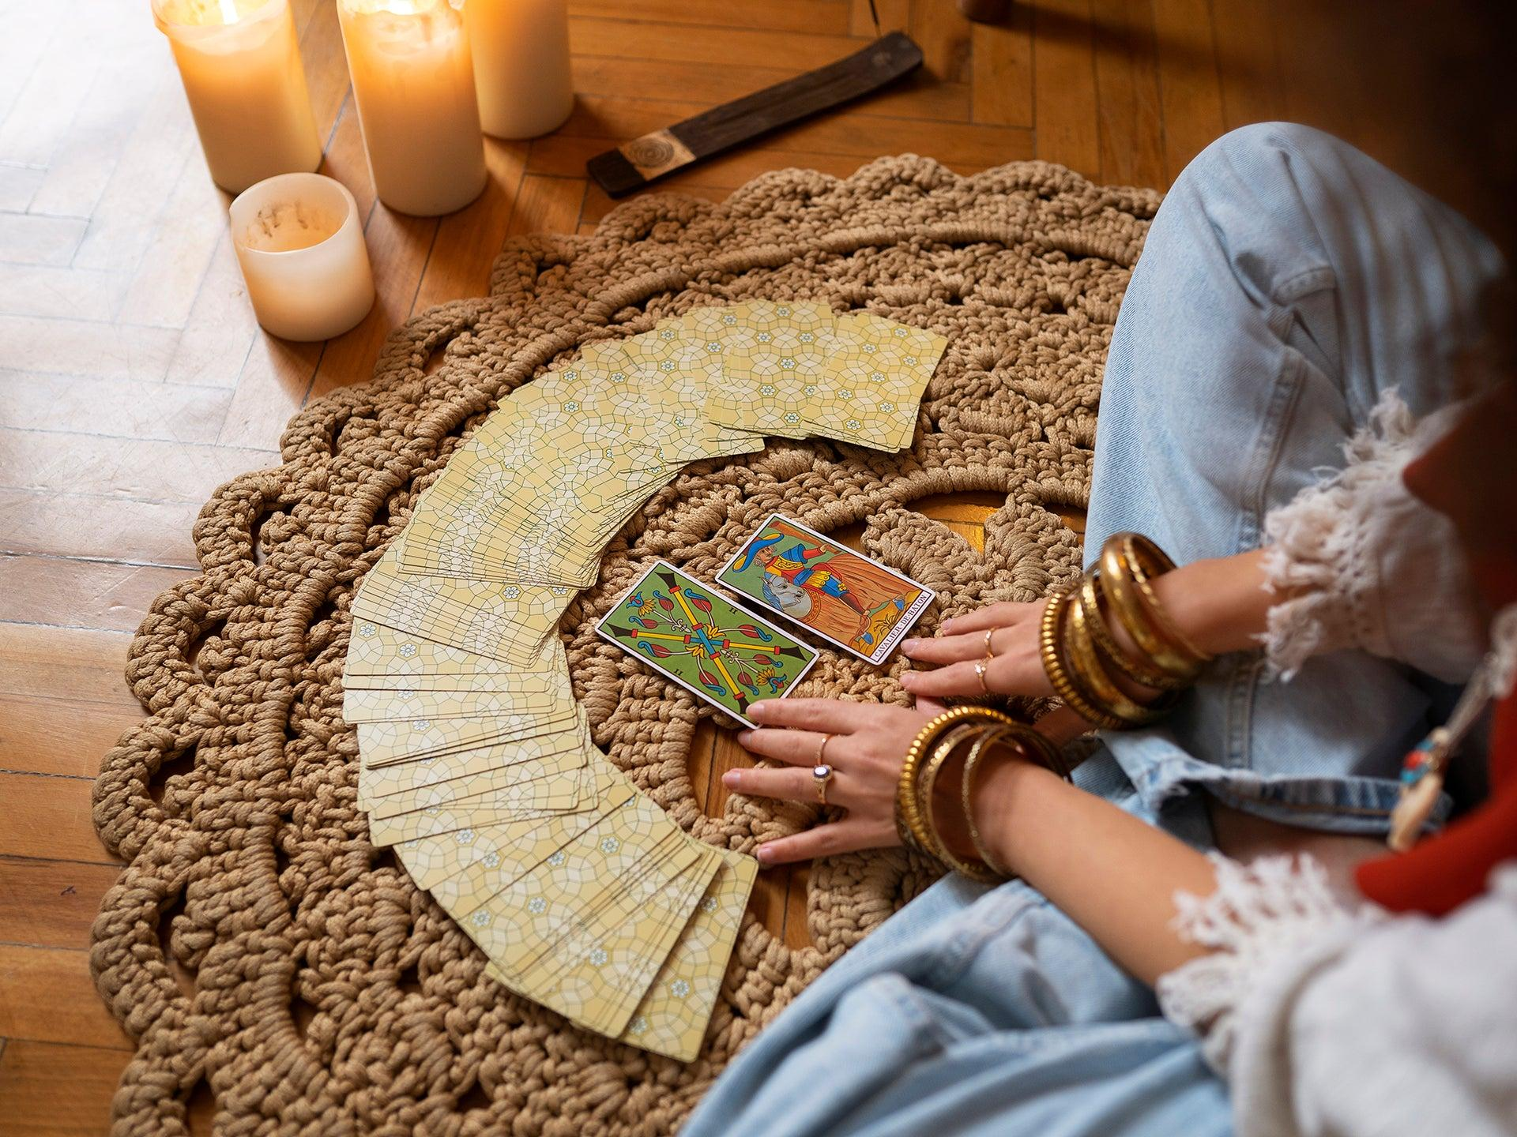
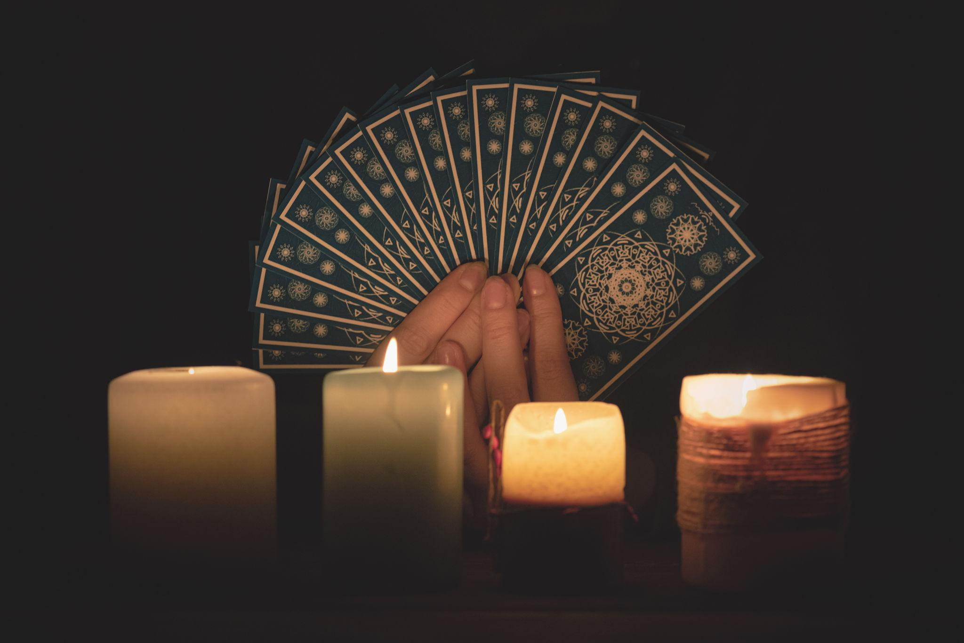

SECTION 2: WHAT YOU WILL GAIN
Layout: 2-column (text + visual)

Left (Text):
H2: What You Will Gain
Bullet Points (with icons):
- Clarity in confusing situations
- Emotional insight and awareness
- Guidance for decision-making
- Stronger connection with your intuition
- Grounded perspective on your current phase

Right (Image):


Icons in the respective order as above:
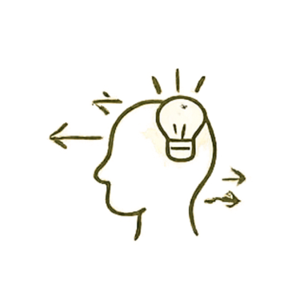
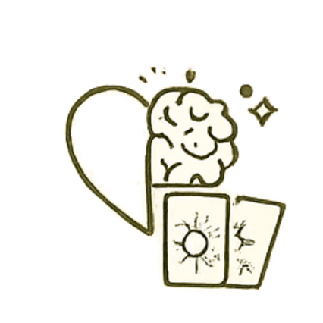
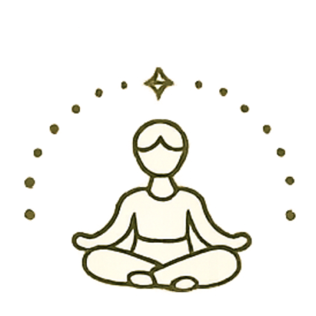
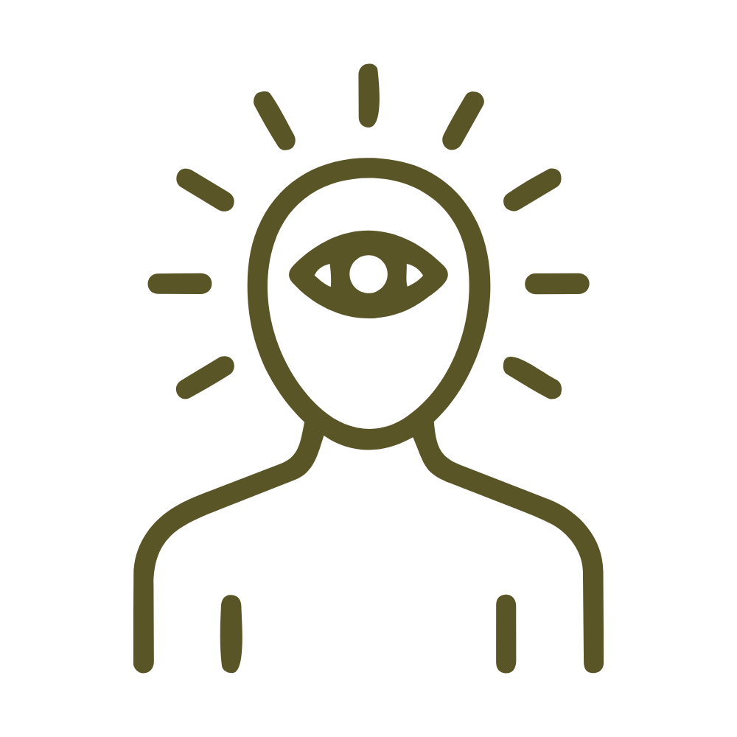



[SECTION 3: WHAT WE CAN EXPLORE]
Layout: Grid (2 columns desktop / 1 mobile)
Card Style: Minimal cards with icon + title + short text

Cards:
1. Life Direction & Decision Clarity
Gain perspective on your path and available choices
2. Relationships & Emotional Patterns
Understand dynamics and recurring patterns
3. Career & Financial Guidance
Clarity on opportunities, blocks, and alignment
4. Inner Blockages & Energy Shifts
Identify fears and limiting beliefs
5. Spiritual Growth & Self-Connection
Reconnect with your inner voice
Icons:

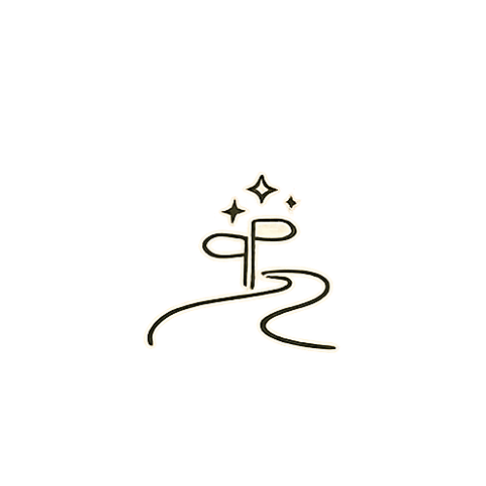


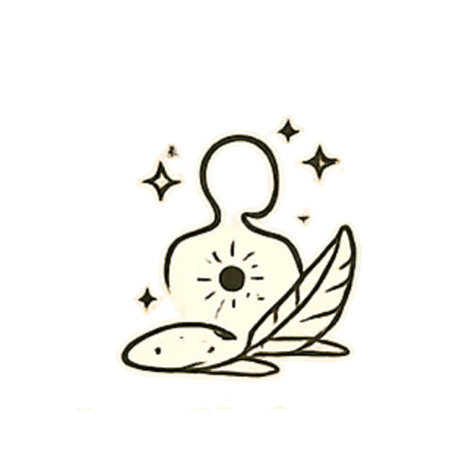
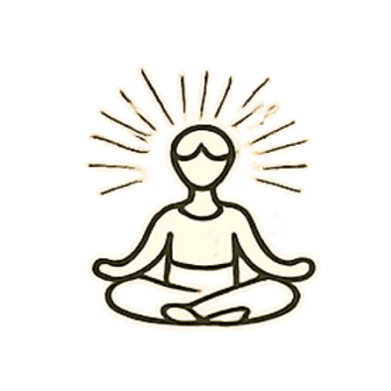

[SECTION 4: HOW THE SESSION WORKS]
Layout: Horizontal steps (or vertical on mobile)

Steps:
- One-on-one guided tarot reading
- Safe, non-judgmental space
- Intuitive + grounded interpretation
- Practical, actionable insights

Supporting Image
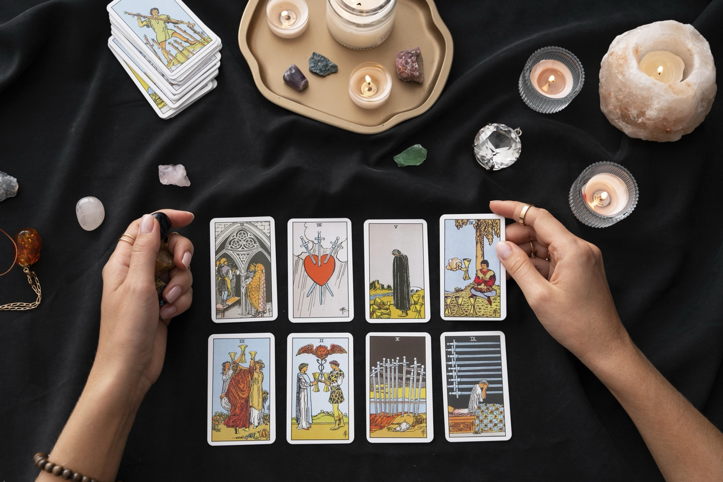

[SECTION 5: OUTCOME OF A SESSION]
Layout: Highlight section (soft background)

Content:
H2: What You Will Walk Away With
Bullets:
- Feel clearer and more centered
- Understand your situation deeply
- Make decisions with confidence
- Recognize patterns influencing your life
- Leave with actionable clarity

[SECTION 6: WHO IS THIS FOR]
Layout: Centered narrow container

Content:
H2: Who Is This For
Bullets:
- Feeling stuck or emotionally overwhelmed
- Facing an important decision
- Seeking clarity in relationships or career
- Want deeper self-understanding
- Ready to look within

[SECTION 7: IMPORTANT NOTE (TRUST BUILDER)]
Layout: Minimal, centered

Content:
H2: Important Note
Tarot is a guidance tool—not a fixed prediction.
Your choices, awareness, and actions shape your life.
We use tarot to empower you—not create dependency.

🔷 [SECTION 8: FINAL CTA]
Layout: Centered, high emphasis

Content:
H2:
Clarity begins when you choose to look within
Subtext:
Your answers are not outside.
They are waiting to be seen.

CTA:
- Primary Button: Book Your Session – ₹555
- Secondary: WhatsApp Enquiry

